Dominic Bumpus Database Design Exercise
Dominic Bumpus
Trine University
SYS—5013-301
Dr. Kelly Wibbenmeyer
October 11, 2025

Entity-Relationship Diagram
The following ER diagram illustrates the structure of the proposed database system for Prestige University. It includes entities, attributes, and the relationships between them. Each section for students, courses, faculty, enrollment, and course pre-requisites has been covered. Data flows between all entities are shown with arrows.
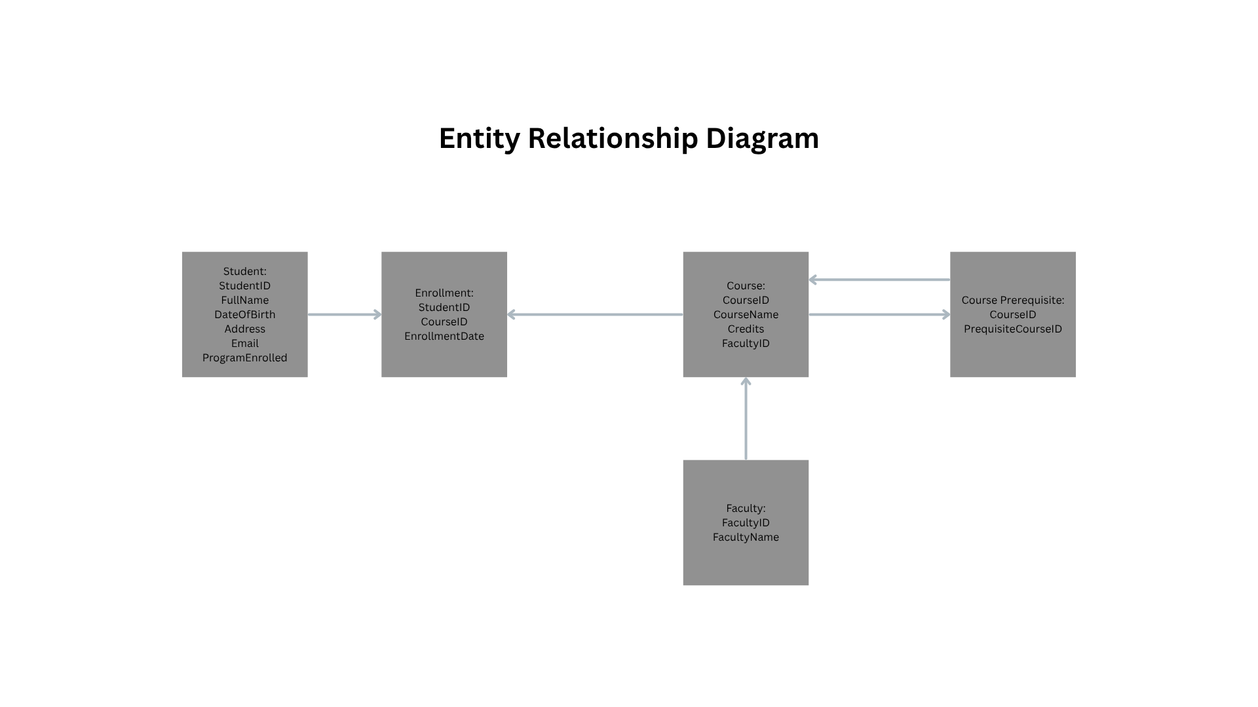

Database Design Explanation

Entities and Attributes
- Student: StudentID, FullName, DateOfBirth, Address, Email, and ProgramEnrolled.
- Course: CourseID, CourseName, Credits, and FacultyID.
- Faculty: FacultyID, FacultyName, and CoursesOffered.
- Enrollment: Junction entity with composite primary key (StudentID + CourseID) and EnrollmentDate.
- CoursePrerequisite: Self-referencing entity with composite primary key (CourseID + PrerequisiteCourseID).

Relationships and Cardinalities
- Student to Course: Many-to-many via Enrollment.
- Faculty to Course: One-to-many.
- Course to CoursePrerequisite: Many-to-many self-referencing.

Design Rationale
The design follows database normalization principles to reduce redundancy and maintain data integrity. Each entity is represented independently, and Enrollment and CoursePrerequisite show what is required for taking a course. A key system enforces referential integrity, ensuring accurate relationships between students, courses, and faculties.

References
GeeksforGeeks. (2025, September 9). Introduction of ER model. GeeksforGeeks. https://www.geeksforgeeks.org/dbms/introduction-of-er-model/
GeeksforGeeks. (2025, September 8). How to draw Entity Relationship Diagrams (ERDs). GeeksforGeeks. https://www.geeksforgeeks.org/sql/how-to-draw-entity-relationship-diagrams/
GeeksforGeeks. (2025, July 23). Database design in DBMS. GeeksforGeeks. https://www.geeksforgeeks.org/dbms/database-design-in-dbms/
Kendall, K. E., & Kendall, J. E. (2024). Systems Analysis & Design. Pearson.

